Aspects to consider:

* User preferences (Could be a vegan, vegetarian, have certain dietary restrictions)
* App should adjust to these preferences
* Could have a survey at the beginning of the log in to better understand the user and tailor their feed to match their choices
* Also if allowed by the user we could also check stores near by for ingredients they may need and connect them to the corresponding website
* Also would be good to consider serious beginners (People who have never cooked before and would like to learn) – We could tailor recipes to then include simple things like how to hold a knife, chopping techniques things to help simplify the cooking process should the user need it.
* Could also have a filter on time (Perhaps the user has limited time to prepare a meal)
* We should consider the copyright laws when choosing recipes to use. I found that for school projects, this may not be something we have to worry about too much. As long as we don’t mean to sell our app. More info in 🡪 [Recipe Attribution (davidlebovitz.com)](https://www.davidlebovitz.com/recipe-attribution/)
* According to the following website 🡪 [The User Experience on Recipe Sites is Broken - Modus Create](https://moduscreate.com/blog/the-user-experience-on-recipe-sites-is-broken/). It is rather annoying to have to scroll back and forth to get to ingredients and then back to the recipe, something we should definitely consider and try to improve.
* “Cook with me” feature could be be very useful in fixing the above issue, since it will include pictures and directions and include the ingredients that need to be added at a specific step
* Option to save recipes offline
* Give users the option to plan recipes for the future and get ingredients in advance
* For students we could have a section, for lunchbox recipes, snacks (healthy??)…We could also add a “use leftovers” section
* Have everything categorized and easy to find
* Motto: “Everyone can cook!”
* We could consider chatbots but I don’t see a use in this case, unless its more of a voice chatbot.
* It would be nice to have a place to determine how much a meal would cost if the user has no ingredients and wants to make the meal according to stores around them
* Consider meals for students (Realistic🡪 noodles, sandwiches, mealprep) (Research needed!!)

According to this website users have the following problems when using recipe apps

From website: [Recipe App Case Study. Everyone can cook. It’s easier when you… | by Velichko Botev | Medium](https://medium.com/@velichko.botev/recipe-app-case-study-986af9c28207#8cc6)

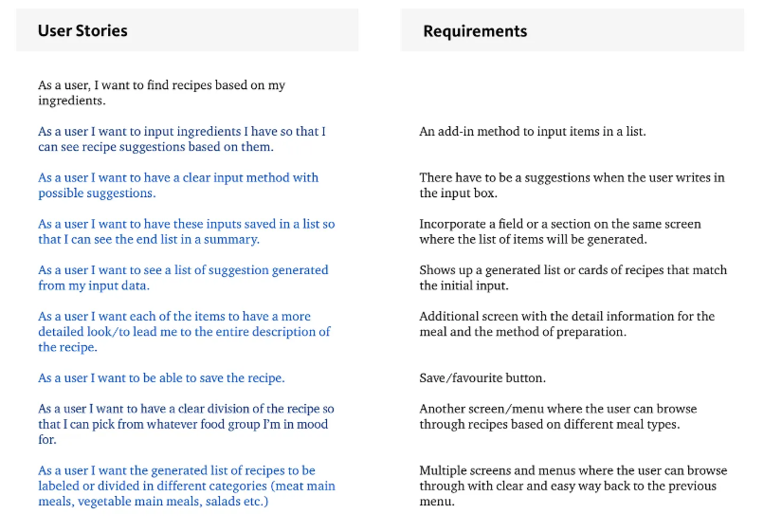

It seems there are apps that already have some of the functionality in our app:

According to this: [Recipe for Success: Must-Have Mobile Apps for Home Chefs | Best Mobile App Awards Blog](https://bestmobileappawards.com/blog/recipe-for-success-must-have-mobile-apps-for-home-chefs). These are the best apps: (Used as inspo to see what works and what doesn’t, could really help design wise)

* Paprika
  + organize recipes, plan meals, and even create grocery lists, special feature: They allow users to download recipes from any site…app design isn’t great if I’m being honest
* BigOven
  + Has a massive library of recipes, allows you to organise your fav recipes, plan meals and create grocery lists. Also has a left overs section and is great for students. They have recipe scanning as well☹ Looks impressive ngl
* Yummly
  + Greatly personalises the users cooking experience. By understanding a users nutritional needs, preferences and their cooking skills. Has a integrated timer and step by step video guides. Has a well thought out interactive cooking mode(Could be used as inspo). Very cool app damn :/
* Mealtime
  + Very nice UI, simple and sleek. Offers practical and personalised cooking solutions. Each recipe is crafted to ensure uses spend only the time required to make a meal. Also offers a consolidated grocery list that is categorized by aisle (Would save time during grocery runs for sure). Also targets students.